

**Artificial Intelligence Systems**

Lab Report # 01

**Submitted by:** Zarmeena Jawad

**Registration No:** B23F0115AI125

**Submitted to:** Dr. Mohsin

Date: 24th February , 2025

# Lab Task 1:Dictionary Manipulation

* 1. Create a dictionary representing a student's information with keys like 'name', 'age', 'grade', and 'subjects'. Perform the following operations:
  2. Add a new subject to the 'subjects' list.
  3. Update the student's age.
  4. Print the student's name and all the subjects they are studying.

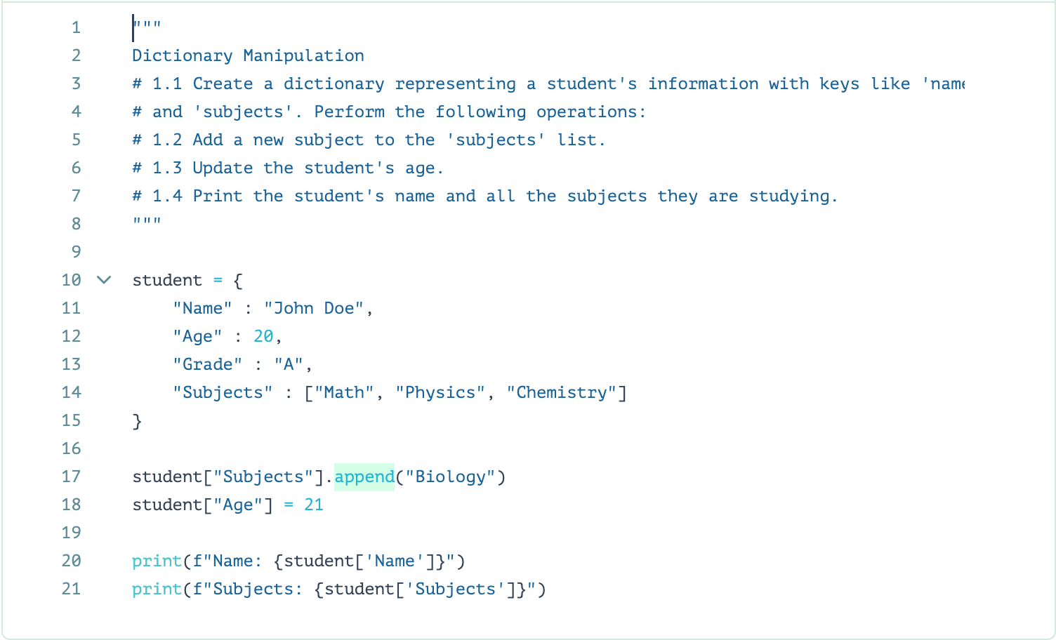

# Task 2: List Operations

* 1. Create a list of numbers and perform the following operations:
  2. Calculate the sum and average of the numbers.
  3. Find the maximum and minimum values in the list.
  4. Remove all duplicate values from the list.

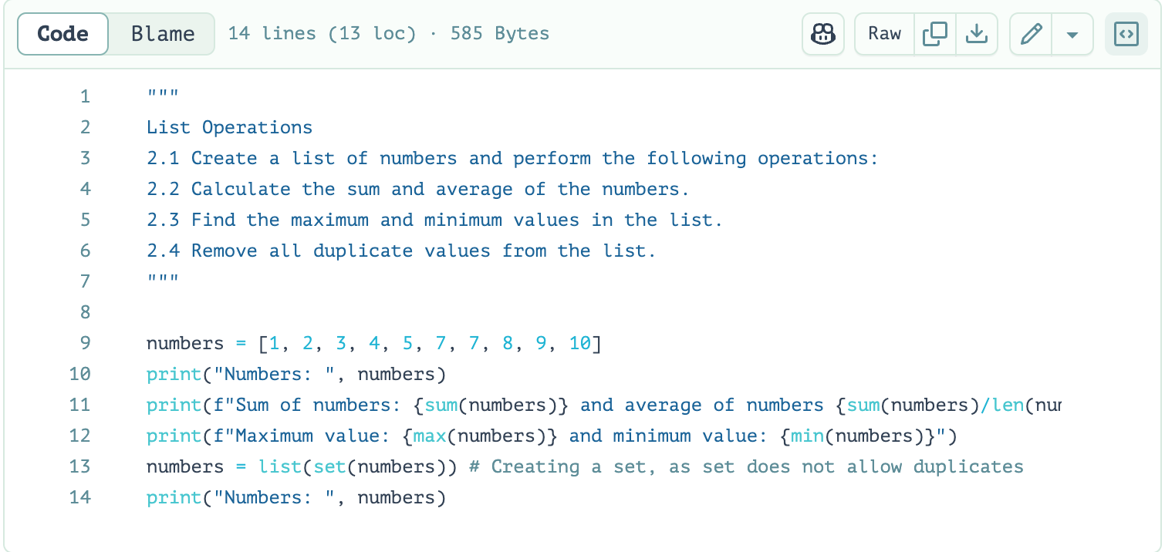

# Task 3: Looping and Lists

* 1. Create a list of names and use a for loop to print a personalized greeting message for each name. For example, "Hello, John!" for the name 'John'.
  2. Use a while loop to find the first name in the list that starts with a vowel.

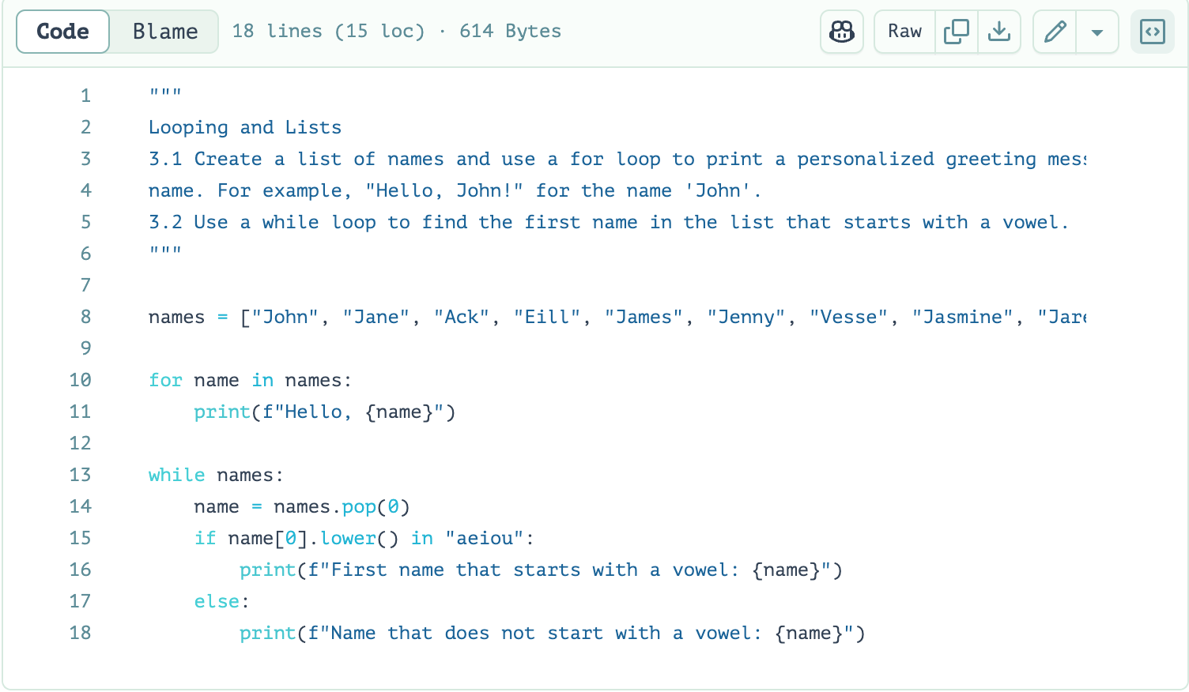

# Task 4: Numpy Array Manipulation

* 1. Import the NumPy library and create a NumPy array with random values.
  2. Calculate the mean, median, and standard deviation of the array.
  3. Reshape the array into a 2D matrix and perform matrix multiplication with another 2D matrix.
  4. Filter the array to get values greater than a certain threshold.

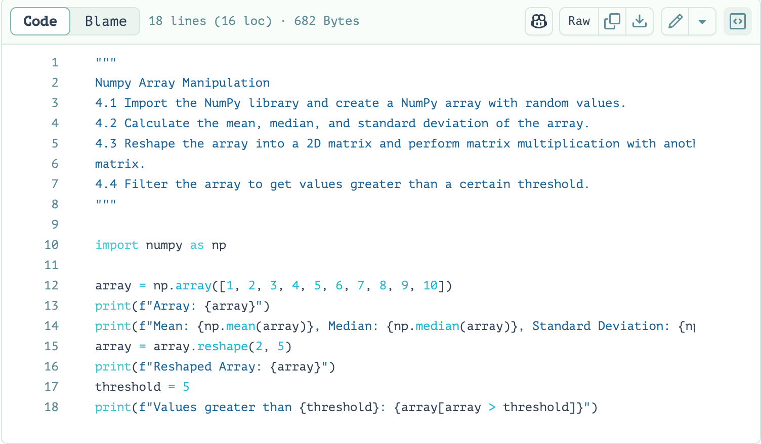

# Task 5: Looping and Dictionaries

* 1. Create a dictionary that represents a simple inventory of items and their quantities.
  2. Use a for loop to iterate through the dictionary and print a message for each item, including its name and quantity.
  3. Write a function that takes a quantity as input and updates the quantities of all items in the dictionary to that value.
  4. Use a while loop to continuously ask the user for an item name and quantity and update the dictionary until the user decides to exit.

# 